### [LucidChart Source](https://www.lucidchart.com/invitations/accept/1630b545-c3fe-4fac-a778-a405f8f9d33b)

### 09/25/18

Rerouted how data is published to Smart Devices

### 

### 09/20/18

Included AWS IoT Core

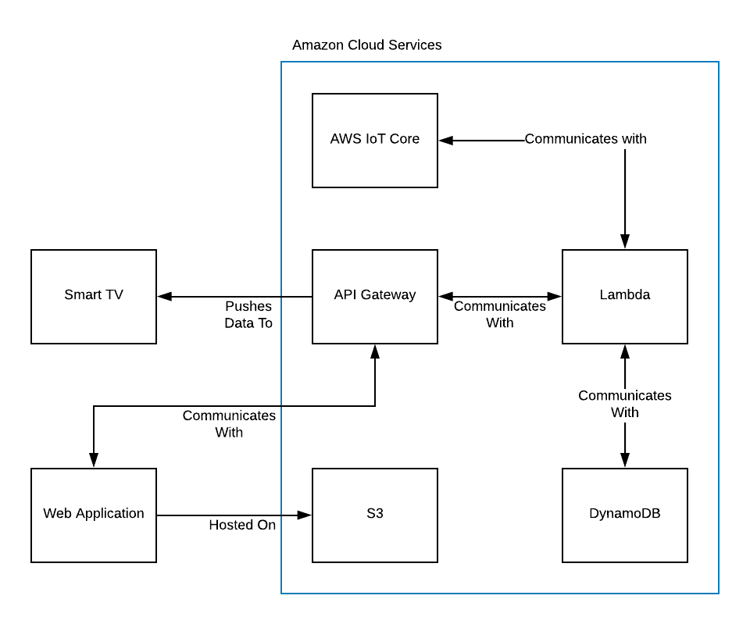

### 09/11/18

Just a quick re-arrangement of the Domain Model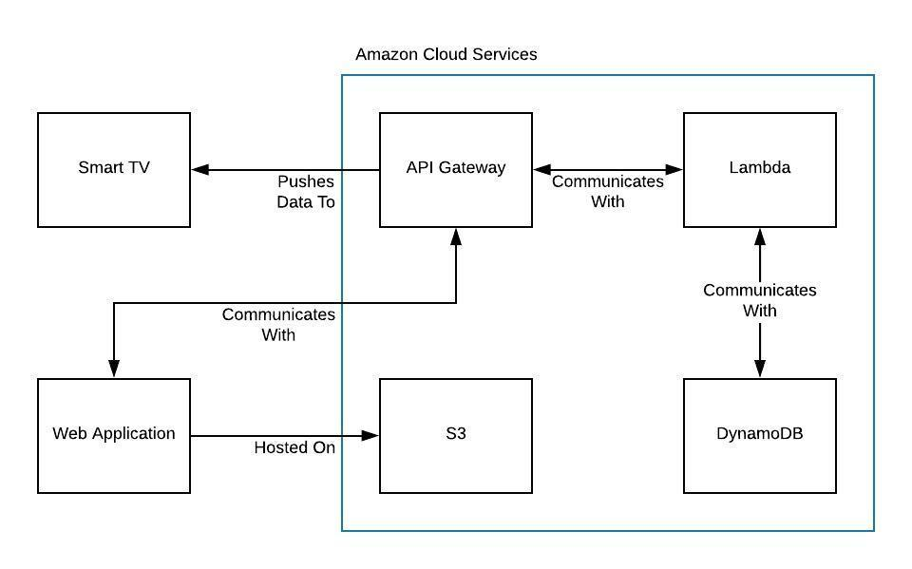

### 09/05/18

In this version we added in the database component into the model. We are still missing the IoT component because we are not sure where it lives relative to the other components. We have also included a trust boundary to signify what elements are part of which system.

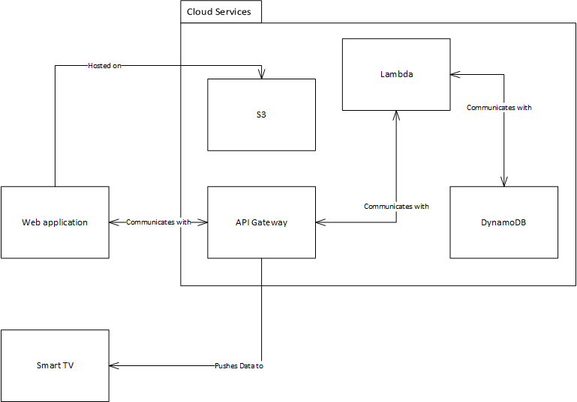

### 

### 09/02/18

In this version we are still trying to understand the tools; this is what we’re currently understanding. We will continue to work on the model as we learn more about the tools.

